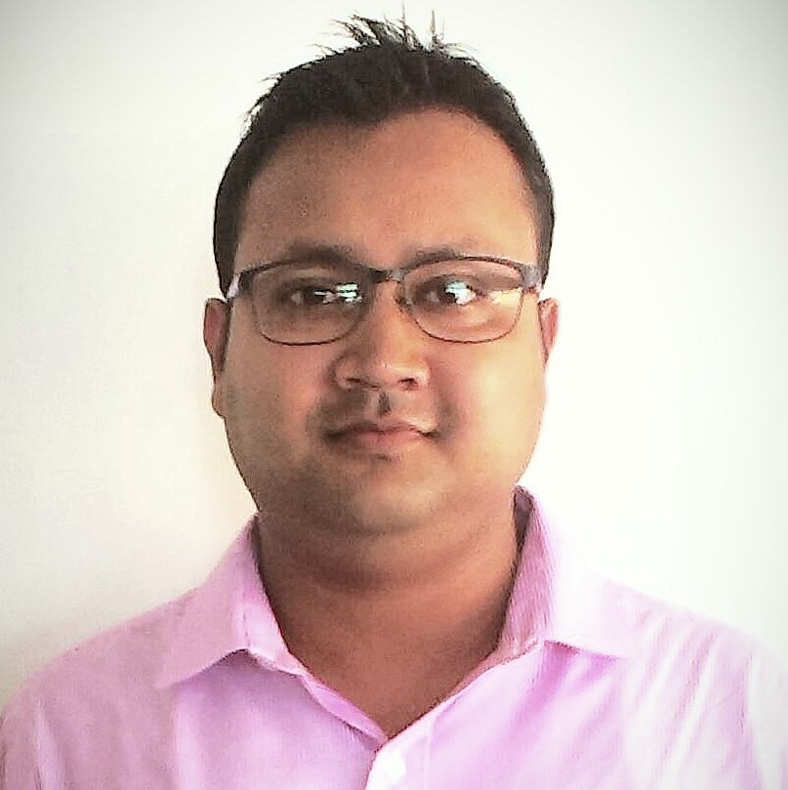
CURRICULUM VITAE

TANUMOY DAS
S/O. –Harendra Chandra Das.
Kali Mohan Road, Tarapur
Silchar
Pin – 788003
Dist – Cachar (Assam)
Mobile: +91 9401281293
Alt No : +919706060637
E-mail ID : - tanumoy19@gmail.com

Career Objective

To Work in an organisation. Which provides me with opportunity to develop my capabilities gives me the chance the potential and grows both as a human being and as a professional i.e. willing to occurs a highly responsible position in a reputed company or organisation.

Strength
- Good logical and analytical skills
- Ability to take initiative and work well in a team
- Commitment to quality.

Educational Qualification

- B.Com. Passed from Guru Charan College Silchar in 2009 (Assam University).

Work Experience

- Worked as a Financial Advisor in BHARTI AXA from January 2009 to August 2009.
- Worked as a Business Development Manager in HDFC LIFE from September 2009 to June 2012.
- Worked as a Senior Agency Manager in SBI Life from July 2012 to 7 January 2015.
- Working as a Select Relationship Manager in IndusInd Bank from 19 January 2015 to 29th May 2015.

Achievements

- Achieved Certificate of Appreciation for ELITE BINDER CHAMPIONS GROUP in the month of October, November & December 2009.
- Achieved the Target set under FLAG and have been promoted as Business Development Manager in July 2010.
- Achieved CERTIFICATE OF APPRECIATION for BUSINESS TERRITORY SUBHARAMBH in the month of July & August 2010 from Mr. Jayesh Tiwaskar Senior Vice President – East & AP.
- Achieved a Trophy for Show of Strengths for the year 2011.
- Achieved Bangkok Tour in the month of January 2012.
- Produced MDRT for CY 2013.
- Achieved double promotion in FY 2013-14.
- Qualified for SBI Life Champions Night at Mumbai for FY 2013-14.
- Qualified for Wealth COC in the month of March 2015 in IndusInd Bank.

Other Qualifications

- Basic Knowledge of Computer, Operating MS Office, Tally 6.3from ICA & Internet Surfing.

Personal Profile
- Date of Birth  - Father’s Name  - Nationality  - Religion  - Sex  - Martial Status  - Language Known | 19th Jan 1984.  Harendra Chandra Das.  Indian.  Hindu.  Male.  Married.  English, Bengali, Hindi & Assamese.

DECLARATION

I hereby declare that the above information is true to the best of my knowledge and belief.

Signature
Date: / /2015
Place: Silchar
(TANUMOY DAS)

